INTERSTITIAL LUNG DISEASE (ILD) aka Diffuse parenchymal lung disease (DPLD)
Dr shayo Md3 notes, harrisons and up to date
So what is lung interstitium?
- it is the space between the alveolar epithelium and the capillary endothelium. Includes terminal airways, lymphatics, connective tissue and blood vessels.
So what is interstitial lung disease therefore?
- It is a diffuse parenchymal lung disease, characterized by varying degrees of inflammation and fibrosis of lung parenchyma
- It includes a large number (>200) of heterogeneous conditions.
What is common in ILD?
- share many common features such as symptoms, radiographic appearance, pulmonary physiology derangement and histology
what are the symptoms of ILD?
- Progressive exertional dyspnea - commonest
- Persistent dry cough - common
- Chest pain
- Hemoptysis
- Fatigue – all
What are the signs of ILD? Mainly in advanced stages
- Crackles, also described as "velcro râles," are a nonspecific finding present in most forms of ILD
- crackles (dry, fine, end-inspiratory)
- Finger clubbing (especially in IPF and asbestosis)
- cyanosis
- Cor pulmonale
Classification of ILD?
- It can be classified by according to cause as: ILD of known cause vs ILD of unknown cause.
- ILD of known cause includes: occupational exposures, drug induced, connective tissue diseases, collagen vascular diseases etc
- ILD of unknown cause includes idiopathic interstial pneumonia and idiopathic pulmonary fibrosis etc
- Most common is the IDIOPATHIC INTERSTITIAL PNEUMONIA
- IPF, sarcoidosis and ILDs related to Connective Tissue Diseases as a group are among the most common forms of ILD.
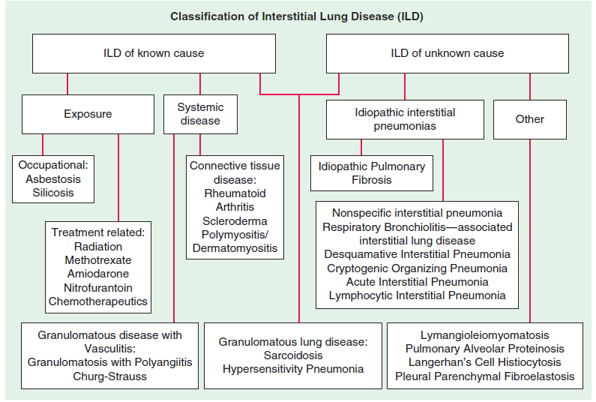

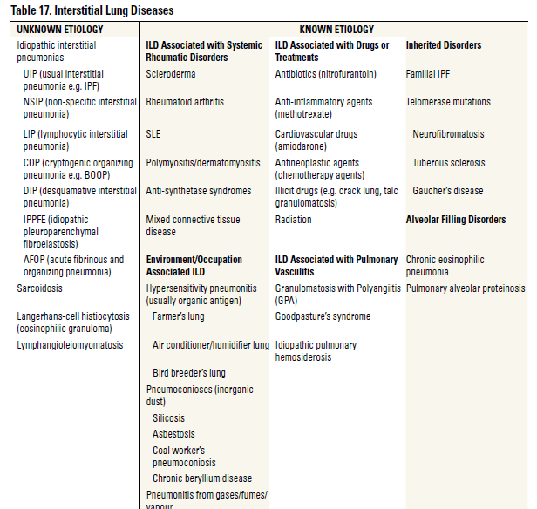

Systemic diseases that can cause ILD?
- Collagen vascular diseases such as Systemic lupus erythematous, Rheumatoid arthritis, Progressive systemic sclerosis, Polymyositis and Dermatomyositis, Sjogren’s syndrome
- Systemic sclerosis
- Sarcoidosis
Occupational exposures causing ILD?
- Asbestos - Shipyard workers, pipe fitters, welders, sheet metal workers, workers involved in automotive repair especially brake lining work.
- Silica causing silicosis - Foundry worker, sandblaster, tunneling, pottery making, polishing and manufacture of glass, tiles and bricks.
- Coal causing coal-workers pneumoconiosis (CWP)
- Metals beryllium and cobalt
- Smoking also a risk factor, though not occupational
- It can be inhalation of either organic or inorganic material
- ILD secondary to inhalation of inorganic dust are referred to as Pneumoconiosis
- ILD secondary to inhalation of organic dust are referred as Hypersensitivity Pneumonitis (chronic bird exposure (pigeons) – granulomatous disease)
- n/b
- asbestos can cause mesothelioma.
- Granulomatous lung disease includes sarcoidosis and hypersensitivity pneumonitis.
Common drugs that can cause ILD?
- Nitrofurantoin antibiotic
- Amiodarone antiarrhythmic
- Methotrexate
- Hydralazine
- isoniazid
- Chemotherapeutics and radiations – bleomycin, azathioprine, rituximab
Diagnosis of ILD?
Age
-Idiopathic Pulmonary Fibrosis occurs most commonly in patients aged >60 and is quite rare among patients aged <50. Lung biopsy shows usual interstitial pneumonia – including fibroblastic foci, temporal and spatial heterogeneity and honeycombing.
- sarcoidosis, Connective TD associated ILD, and less common ILD such as LAM, pulmonary Langerhans cell Histiocytosis (PLCH) tend to present between the ages of 20 and 40.
Sex
- LAM (and related disorder tuberous sclerosis) , many CTD such as SLE frequently diagnosed in young women.
- RA associated ILD is more common among men. IPF and occupational/exposure-related ILDs (likely due to work related exposures that tend to differ between men and women) are more common among men.
Past medical history
- history of a CTD or a history of symptoms commonly associated with a CTD (e.g., Raynaud’s phenomena).
- A history of malignancy is important; malignancies can be associated with Dermatomyositis associated COP and sarcoid-like reactions.
- A history of asthma and allergic rhinitis might suggest a diagnosis of eosinophilic GPA.
Drug history:
- Nitrofurantoin, Amiodarone, Methotrexate, bleomycin, azathioprine, rituximab.
Family History:
- The percentage of pulmonary fibrosis that is familial, as opposed to idiopathic, varies by study, with estimates ranging from <5% to as high as 20%.
- genetic factors for pulmonary fibrosis (mucin gene [MUC5B]) and telomerase reverse transcriptase gene [TERT]) appear to be associated with both familial and idiopathic forms of pulmonary fibrosis similarly.
Social history:
- smoking
- occupational exposure – as above
- chronic bird breeding
Lab investigations
- positive anti-cyclic citrullinated peptide [anti-CCP] antibody for RA
- pulmonary function test - Most forms of ILD will eventually result in a restrictive deficit on pulmonary function testing. i.e reduced total lung capacity and forced vital capacity.
Tests used to diagnose ILD?
- Chest xray
- Ct scan
- PET scan
- Pulmonary function tests
- Lung biopsy
- ACE test - sarcoidosis
Chest xray findings:
- Silicosis - upper lobe nodules with egg shell calcifications of hilar nodes.
- Hilar or Mediastinal adenopathy in Sarcoidosis
- Pleural involvement in Asbestosis and Connective tissue diseases
- Upper lobe involvement in Ankylosing spondylitis, Berylliosis, Histiocytosis X, Silicosis, Chronic hypersensitivity pneumoniti

